H.T No
Regulations:
A17

Sreenidhi Institute of Science and Technology
(An Autonomous Institution)
Code No: 6U101 Date: 27-June-2019 (FN)

M.Tech I-Year I-Semester External Examination, June - 2019 (Supplementary)
DIGITAL SYSTEM DESIGN (DSCE)

Time: 3 Hours Max.Marks:75

Note: a) No additional answer sheets will be provided.
b) All sub-parts of a question must be answered at one place only, otherwise it will not be valued.
c) Missing data can be assumed suitably.

Part - A Max.Marks:25

Answer all QUESTIONS.

1. | Analyze control logic for sequence detector. | [3M]
2. | Define path sensitization techniques. | [3M]
3. | What is signature analysis? Explain. | [3M]
4. | Write the principal of distinguishing tree. | [3M]
5. | Give the diagram of three inputs, five product terms and four outputs of PLA structure. | [3M]
6. | What are cycles and hazads? Explain. | [2M]
7. | Realize a multiplexer with a PLA. | [2M]
8. | Mention the merits and demerits of transition count testing. | [2M]
9. | What are the merits and demerits of Merger diagrams? | [2M]
10. | How to Convert a mealy machine to Moore Machine? | [2M]
Part – B Max.Marks:50
ANSWER ANY FIVE QUESTIONS. EACH QUESTION CARRIES 10 MARKS.

11. | a) | Draw the flowchart for Dice game and explain its operation with SM chart. | [5M]
 | b) | Explain the difference between flowchart and SM chart with symbols. | [5M]
12. | a) | Determine the minimal sum-of-product form for the expression  f(w, x, y, z)= ∑m (0 ,2, 4, 9, 11, 13, 15, 15) + ∑ m(1, 5, 7, 10)  and give the tabular method. | [5M]
 | b) | Explain the different Faults presented in combinational circuits with examples. | [5M]
13. | a) | Discuss various test patterns with examples. | [5M]
 | b) | Explain with example, how the output response is compacted using exhaustive testing? | [5M]
14. | a) | Describe the design of fault detection experiments for the sequential circuits. | [5M]
 | b) | Design the steps to generate the complete test sequence for Sequential machine M of table.  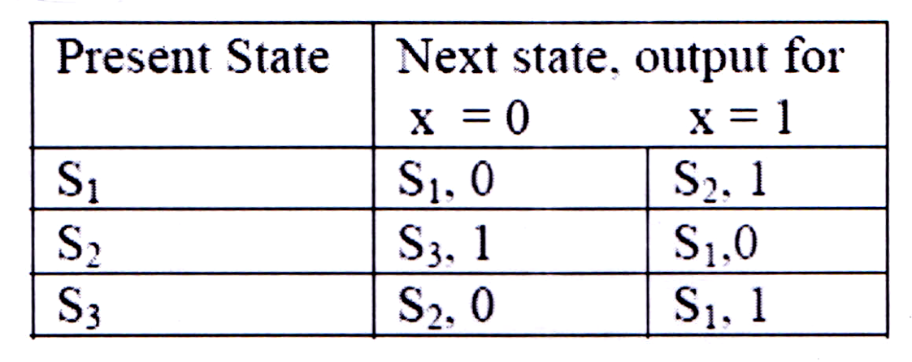 | [5M]
15. | a) | Draw the PLA block diagram and explain its operation with example. | [5M]
 | b) | Discuss Test generation and Testable PLA Design. | [5M]
16. | a) | Find a circuit that has no static hazards and implement the Boolean function  f(A, B, C, D)=∑(0, 2, 6, 7, 8, 10, 12). | [5M]
 | b) | What are the capabilities and limitations of FSM? Explain. | [5M]
17. | a) | Analyze the problems in designing asynchronous sequential circuits and also explain how they are rectified with an example? | [5M]
 | b) | What is the relation between testing and fault tolerance? | [5M]

-- 00 -- 00 –

